**Main Screen:**

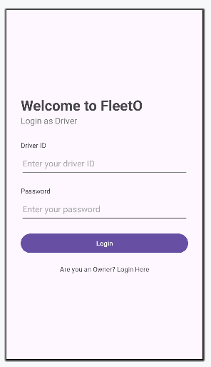  
Drivers can Login here. There is text at the bottom that leads to another screen for the owners to login.

**Owner Login:**

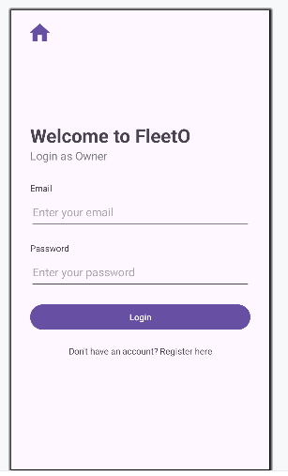

Owners can login here. If they do not have an account, they can click the text at the bottom to go to a new screen. If they want to go back to the driver screen, they can click the home button at the top.

**Owner Register:**

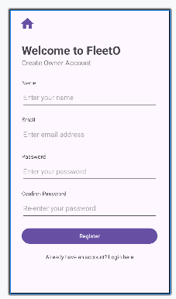

A simple sign-up page for Owners that want to use the app. The basic checks are in place to make sure each owner is unique. If they want to go back to the driver screen, they can click the home button at the top.

**Admin Dashboard:**

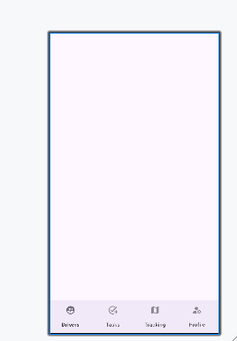

The admin dashboard has a bottom navigation bar. The user can press each button and the screen above the bar will change according to the button. It is set to show the Profile Screen by default.

**Profile Screen:**

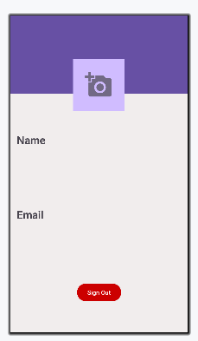

A simple profile screen that shows the data of the user. We have not added a way to add a picture yet because of the limited time. The user can press the Sign Out button to log out. The bottom Navigation bar is present in the app (unable to show it right now as some features are unavailable while we work on the backend). In future versions, this screen will have an edit profile button as well as more information about the Owner such as their Vehicles etc.

**Drivers Screen:**

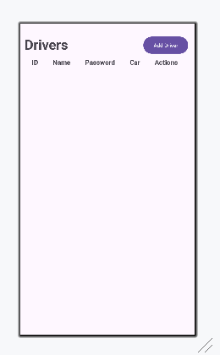

A screen where an “Owner” can see the drivers under him and see their information. The Add Driver button leads to a new screen where the owner can add a new driver. The bottom Navigation bar is present in the app (unable to show it right now as some features are unavailable while we work on the backend).

**Add Drivers Screen:**

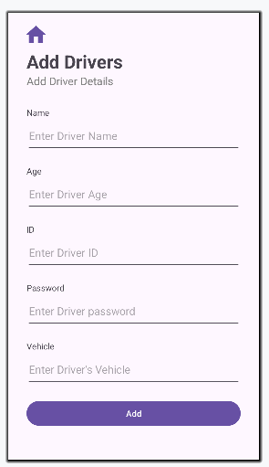

The Owner/Admin can add new drivers. This adds their information to the database where we can use it elsewhere in the app.

**Task Management Screen:**

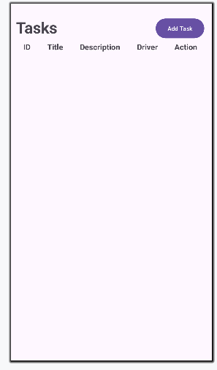

A screen where an “Owner” can see the tasks assigned to the drivers under him and see their information. The Add Task button leads to a new screen where the owner can assign a driver a new task. The bottom Navigation bar is present in the app (unable to show it right now as some features are unavailable while we work on the backend).

**Add Task Screen:**

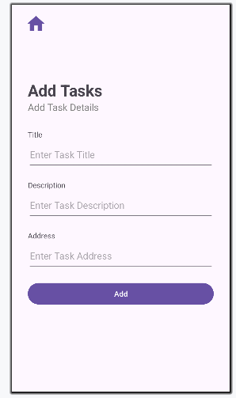

The Owner/Admin can assign new tasks to drivers. This adds their information to the database where we can use it elsewhere in the app.

**Driver Dashboard:**

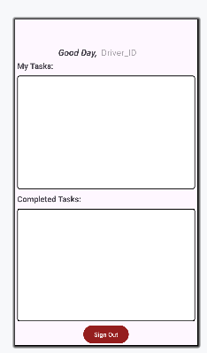

The driver can see their assigned tasks and also their completed tasks. By clicking on a task under “My Tasks:” , they can mark it as done.